Operating System Lab (N-PCCCM401P)



S.B. JAIN INSTITUTE OF TECHNOLOGY
MANAGEMENT & RESEARCH, NAGPUR

Practical 02

Aim: To understand and demonstrate the use of basic commands in different operating systems (Windows, Linux, and UNIX) for managing files, directories, permissions, and user interactions through a terminal or command-line interface.
Name: Manas Ajay Gupta
USN:CM24017
Semester / Year:
Academic Session:
Date of Performance:
Date of Submission:

Operating System Lab (N-PCCCM401P)
- Aim: To understand and demonstrate the use of basic commands in different operating systems (Windows, Linux, and UNIX) for managing files, directories, permissions, and user interactions through a terminal or command-line interface. 

- Objectives: 

- To learn and practice fundamental command-line operations for file and directory management.
- To explore and utilize user and permission management commands effectively.
- To enhance system administration skills by working with commands across different operating systems.

- Requirements:
Hardware Requirements:
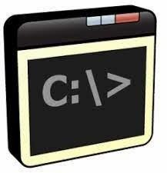
  - Processor: Multi-core CPU, Intel Core i3 (3.0 GHz) or higher
  - RAM: Minimum 4 GB (8 GB recommended for optimal performance)
  - Storage: 100 GB HDD or SSD (Solid State Drive) for faster access • Network Interface: Ethernet or Wi-Fi adapter for connectivity

Software Requirements:

  - Operating System: Windows 10/11, Linux (Ubuntu 20.04/CentOS 8), UNIX-based OS
  - Command-line Interface: PowerShell or Command Prompt (Windows), Terminal (Linux/UNIX)
  - Text Editor: Nano, Vim, or Visual Studio Code for file editing
  - Administrative Privileges: Superuser (Linux/UNIX) or Administrator (Windows) access

- Theory:
In system administration, command-line interfaces (CLI) are essential tools for managing and interacting with operating systems like Windows, Linux, and UNIX. Commands allow users to perform various tasks such as navigating directories, managing files, controlling permissions, and monitoring system performance. Each operating system provides a set of builtin commands, such as ‘man’, ‘ls’, ‘cd’, ‘mkdir’, and ‘chmod’, to facilitate efficient system management. Understanding these commands and their syntax is crucial for automating tasks, enhancing security, and ensuring optimal system functionality. This practical aims to develop foundational skills in executing and applying basic commands across different platforms.
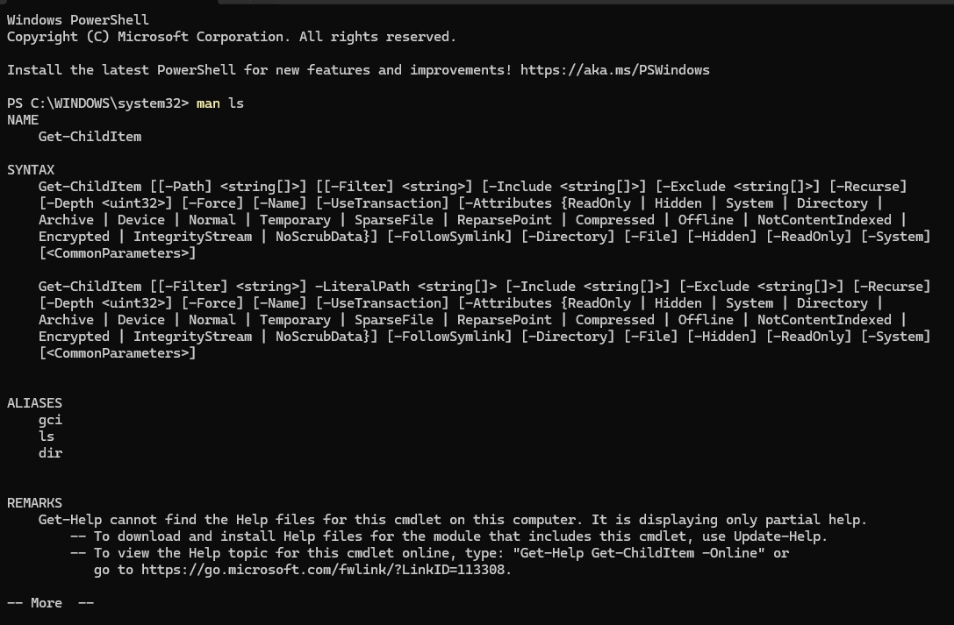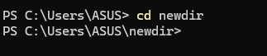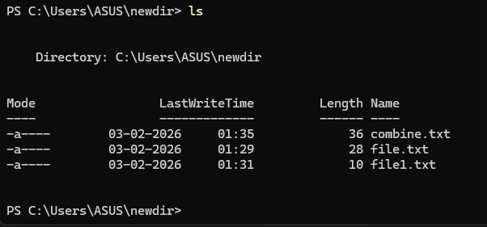
Operating

System

Lab

(
N
-
PCCCM401P)

❖

Commands:

1.

Display

User

Manual

of

a

Command

-

Functionality:

Shows

the

manual

page

with

details

about

a

command’s
usage, options, and arguments.

-

Syntax:

man

<
command
>

-

Example:

man

ls

2.

Change

Current

Working

Directory
.

-

Functionality:

Changes

the

terminal’s

current

working

directory.

-

Syntax:

cd

<
directory
-
path>

-

Example:

cd

/home/user/Documents.

3.

List

Contents

of

the

Current

Directory.

-

Functionality:

Lists

all

files

and

directories

in

the

current

location.

-

Syntax:

ls

-

Example:

ls

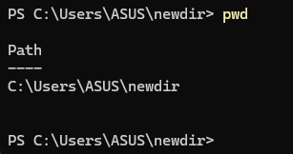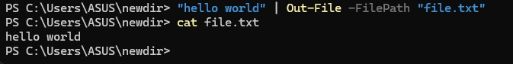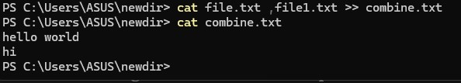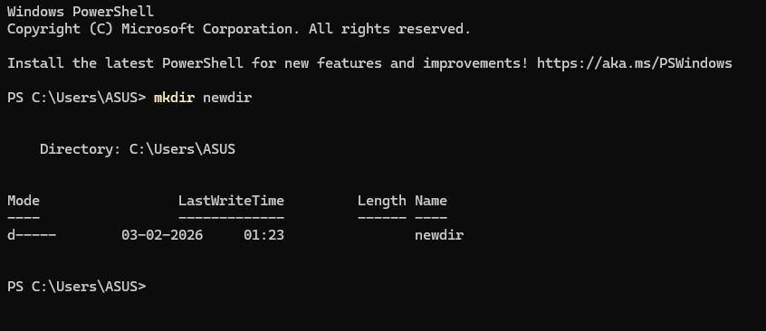
Operating

System

Lab

(
N
-
PCCCM401P)

4.

Read/Modify/Concatenate

Text

Files.

-

Functionality:

Displays

or

manipulates

file

content.

-

Syntax:

-

Read: cat
<
filename
>

-

Modify:

‘nano

>
<
filename

-

Concatenate:

cat

<
file
1>

<
file
2>

>

>
<
outputfile

5.

Create

a

New

Directory
.

-

Functionality:

Creates

a

new

directory

at

the

specified

path.

-

Syntax:

mkdir

directory
<
-
name

-

Example:

mkdir

newdir

6.

Display

Current

Working

Directory.

-

Functionality:

Prints

the

current

directory

path.

-

Syntax:

pwd

-

Example:

pwd

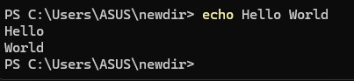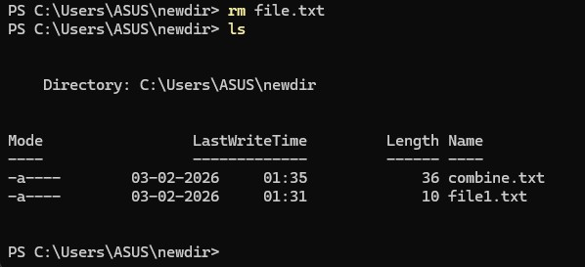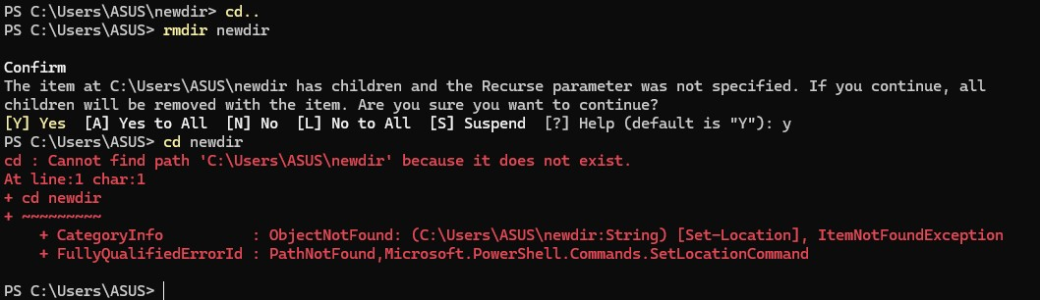
Operating

System

Lab

(
N
-
PCCCM401P)

7.

Write

Arguments

to

Standard

Output.

-

Functionality:

Prints

the

provided

string

or

variables.

-

Syntax:

echo

arguments
<
>

-

Example:

echo

Hello

World

8.

Remove

a

File
.

-

Functionality:

Deletes

a

specified

file.

-

Syntax:

rm

<
filename
>

-

Example:

rm

file.txt

9.

Delete

a

Directory.

-

Functionality:

Removes

an

empty

directory.

-

Syntax:

rmdir

<
directory
-
name>

-

Example:

rmdir

olddir
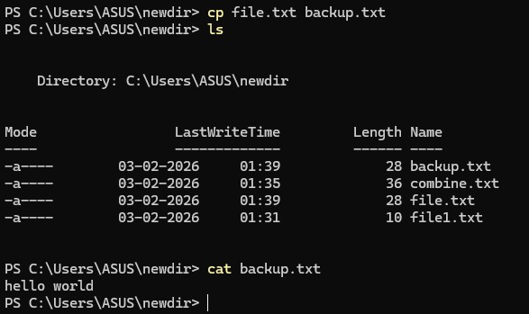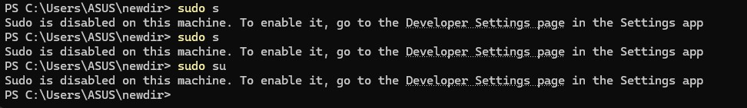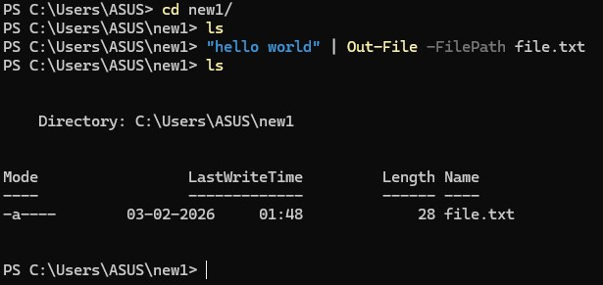
Operating

System

Lab

(
N
-
PCCCM401P)

10.

Copy

a File

or

Directory.

-

Functionality:

Copies

a

file

or

directory

to

a

destination.

-

Syntax:

cp

>
source
<

<
destination
>

-

Example:

cp

file.txt

backup/

11.

S
witch

to

Root

User.

-

Functionality:

Gains

root

privileges

temporarily.

-

Syntax:

sudo

su

-

Example:

sudo

s

12.

Move

Files

or

Directories.

-

Functionality:

Moves

or

renames

files

and

directories.

-
Syntax:

mv

<
source
>

<
destination
>

-

Example:

mv

file.txt

newdir/

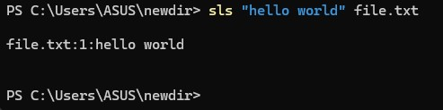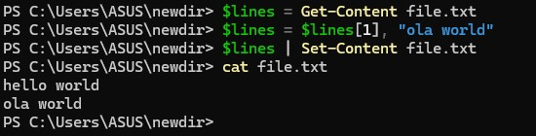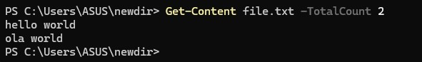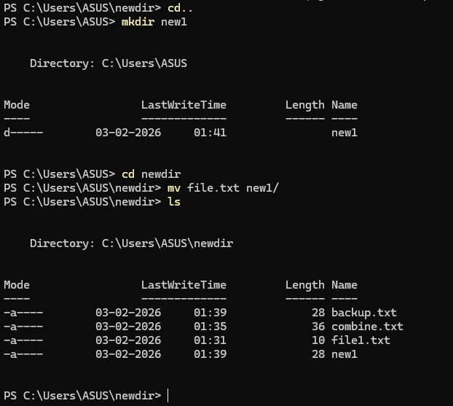
Operating

System

Lab

(
N
-
PCCCM401P)

13.

S
earch

for

a

String

in

a
File.

-

Functionality:

Searches

for

a

specific

word

or

pattern

in

a

file.

-

Syntax:

grep

"<string>"

>
<
file

-

Example:

grep

"error"

log.txt

14.

Print

Top

N

Lines

of

a

File.

-

Functionality:

Displays

the

first

N

lines

of

a

file.

-

Syntax:

head

-
n

>
<
N

<
file
>

-

Example:

‘head

-
n

10

file.txt’

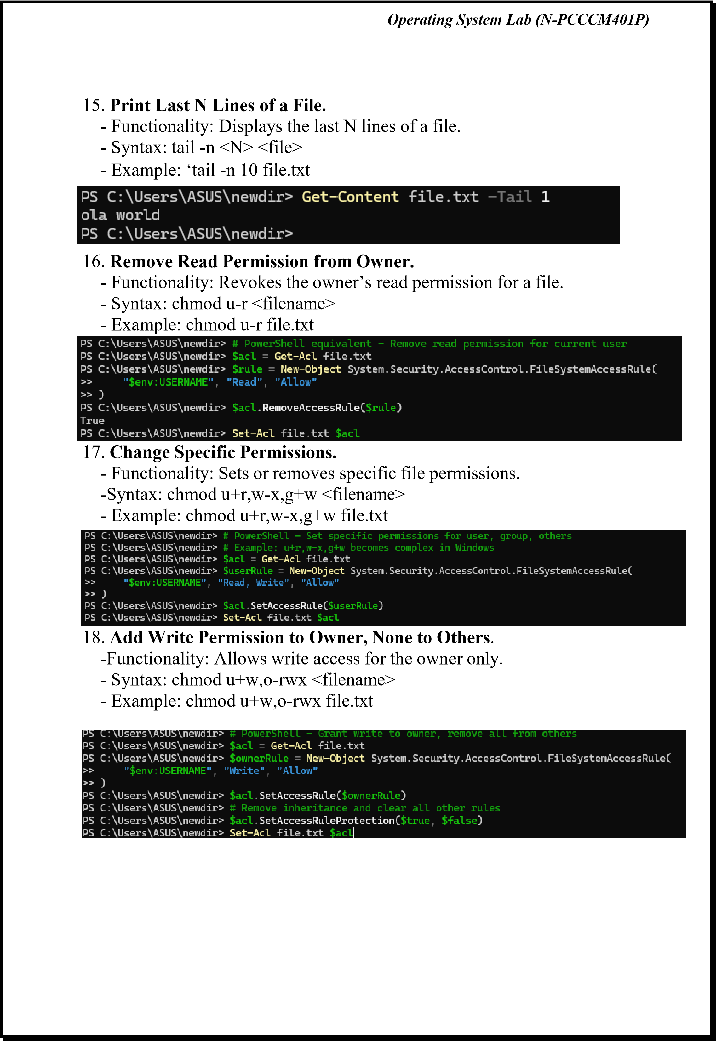
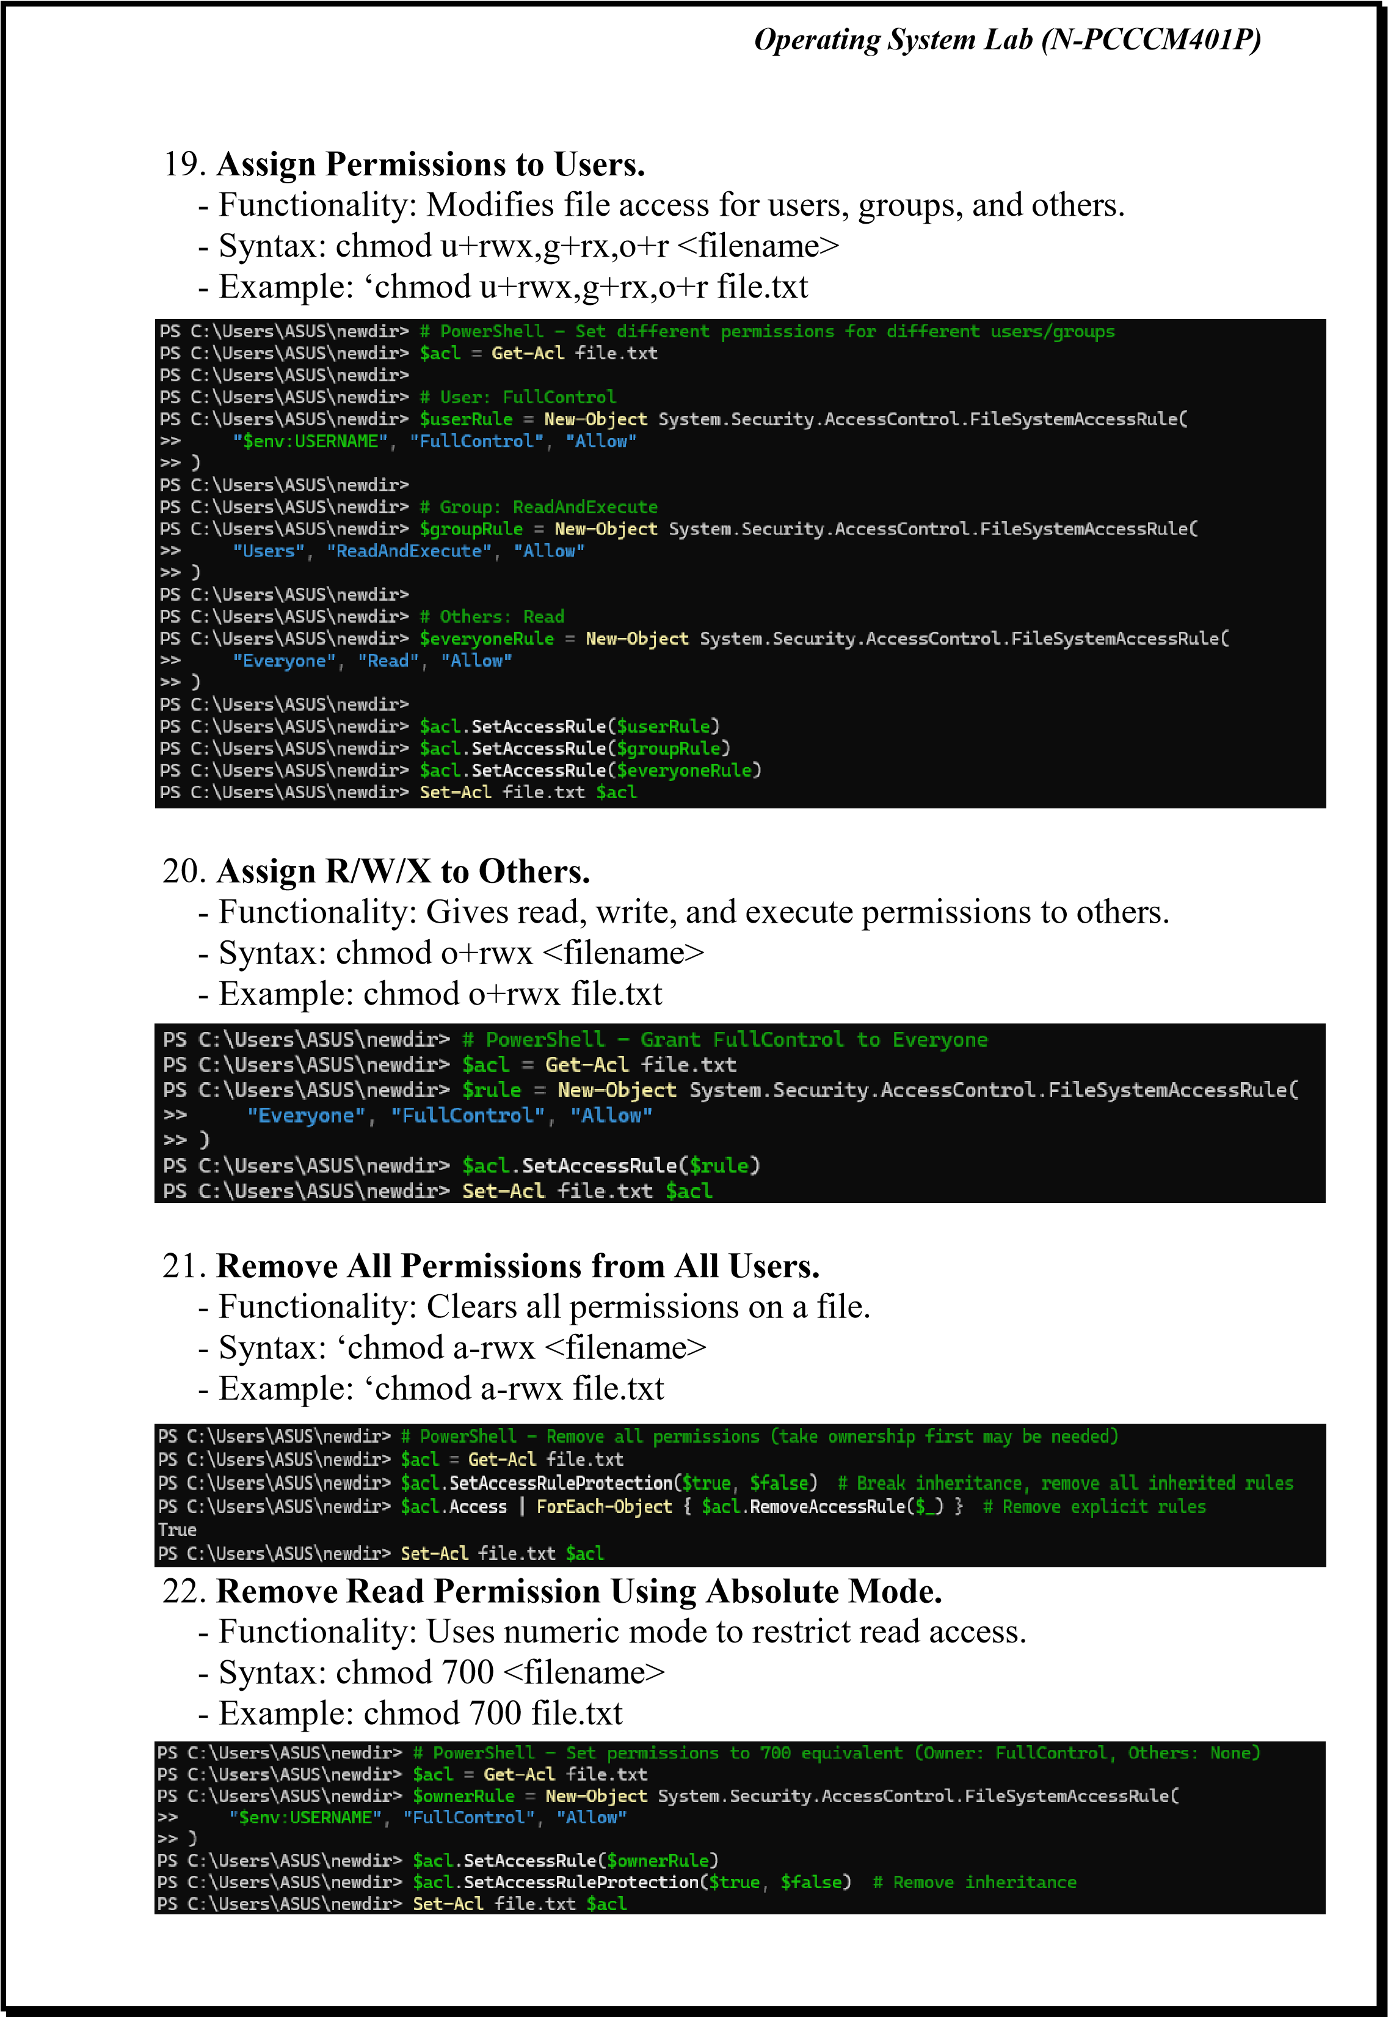
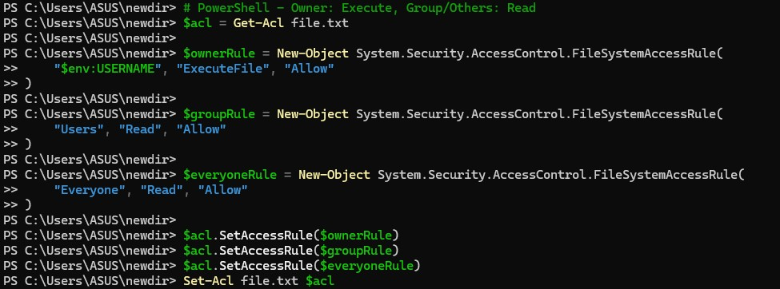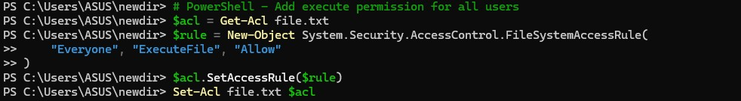
Operating

System

Lab

(
N
-
PCCCM401P)

23.

Set

R/W

for

Owner,

None

for

Group/Other.

-

Functionality:

Assigns

permissions

in

numeric

mode.

-

Syntax:

chmod

600

>
<
filename

-

Example:

chmod

600

file.txt’

24.

Add

Execute

for

Owner,

Read

for

Group/Others.

-

Functionality:

Adds

execution

and

read

access.

-

Syntax:

chmod

u+x,g+r,o+r

<
filename
>

-

Example:

chmod

u+x,g+r,o+r

file.txt

25.

Add

Execute

Permission

to

All

Users.

-

Functionality:

Enables

execution

by

everyone.

-

Syntax:

chmod

a+x

<
filename
>

-

Example:

chmod

a+x

script.sh

Operating System Lab (N-PCCCM401P)

- Conclusion: In conclusion, understanding and using essential operating system commands like ‘ls’, ‘cd’, ‘cp’, ‘mv’, and ‘chmod’ enables efficient file management, navigation, and permission control. Tools like ‘grep’,
‘head’, and ‘tail’ enhance data processing. Mastery of these commands improves system administration, task automation, and overall system security and performance. 
- Discussion Questions: 
  - What is the significance of the pwd command in a Linux environment?
  - Explain the function of the cp command and its common options.
  - How does chmod 700 affect file permissions, and what does each digit represent?
  - Describe the difference between head and tail commands in Linux.
  - What is the purpose of the grep command, and how is it used with regular expressions?

- References: 
https://ubuntu.com/tutorials/command-line-for-beginners#1-overview https://www.geeksforgeeks.org/25-basic-ubuntu-commands/

Date: / /2026 Signature
Course Coordinator
B.Tech CSE(AIML)
Sem: 4 / 2025-26
Department of Emerging Technologies, SBJITMR, Nagpur.

-

